**Question**

**Configure your system in such a way that any user of your system creates a file then there should not be permission to do any activity in that file.**

**Note:- Don’t use the chmod command.**

**My Approach**

**For this I use the concept of umask.**

**umask** is a command in Unix and Unix-like operating systems that is used to set default permissions for newly created files and directories. It stands for "user file creation mask" and is a bitmask that controls which permissions are removed from the default permissions of new files and directories.

**Step 1 : Set umask value = 777**

**Command = umask 777**

After this every file and directory that will be created in the system will have no permissions.

**For files:** No one (neither the owner, nor the group, nor others) will have any permission to read, write, or execute the file.

**For directories:** No one (neither the owner, nor the group, nor others) will have any permission to list contents, create files, or access files within the directory.

**Example:**

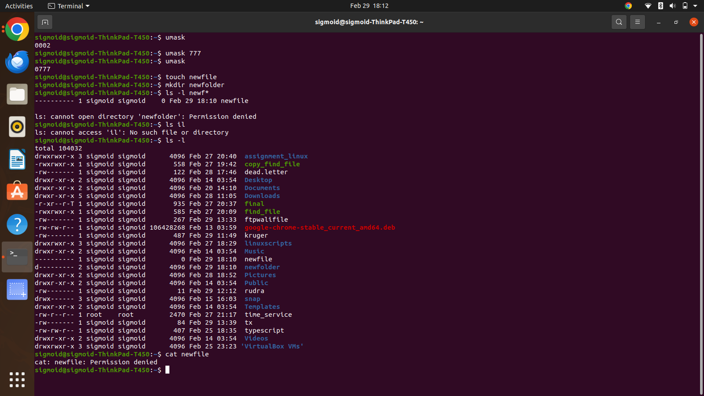

We can see here that after setting the umask value as 777, we create a file and directory and both of this have no permission(read, write and execute) at all**.**